July 31, 2026

«TSD»
«TSD_Title»
«Hospital_Name»
«Street»
«Street_2»
«City_State_Zip»

PRODUCT RETRIEVAL NOTIFICATION

Dear «TSD_Salutation_1»:

This letter is in regard to the unit(s) listed below which was/were distributed to your hospital on the indicated date(s). This letter is to notify you that the donor of the unit(s) listed was found to have a reactive screening test for a significant infectious disease marker, (Anti-HCV, Anti-HIV), on . Last negative donation on . Additional confirmatory testing is being performed. Regulatory requirements mandate that we report this information to consignees for the purpose of quarantine, even if the components may no longer appear to be in date. Please be assured that the donated blood was tested and found non-reactive/negative for all required viral markers.

At this time, we do not recommend recipient notification. We will notify you regarding the subsequent test results.

Since the information may be reported to the Food and Drug Administration, Center for Biologics Evaluation and Research, it is necessary to know the final disposition of all units. Please complete the form below and return by fax to Medical Surveillance at 909.386.6817 as soon as possible. Please return any unit(s) listed below to the blood center (DO NOT TRANSFUSE).

If you have questions regarding this matter, please do not hesitate to contact me or Medical Surveillance at 1.800.879.4484 or 909.885.6503.

Sincerely yours,

REPLY REQUESTED

COMPONENT FINAL DISPOSITION. Please complete final disposition and fax to Medical Surveillance.

Completed by: Date:

«Hospital_Name»

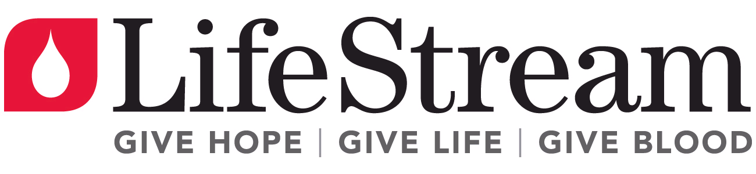

component follow-up
for REACTIVE HIV/HCV SCREENING TEST
donor id Sub #

Reviewed  by/Date  RR Conf |  | Date  Sent  RR Conf |  | Date  Disposition  Returned |  | Hospital | Unit Number | ABO Type | Date Drawn | Product | Date Shipped | Final Disposition | Date of Final Disposition
To be completed by Medical Surveillance.

First Review Reactive Results:
(Initials/Date)

First Review Confirmatory Results:
(Initials/Date)

